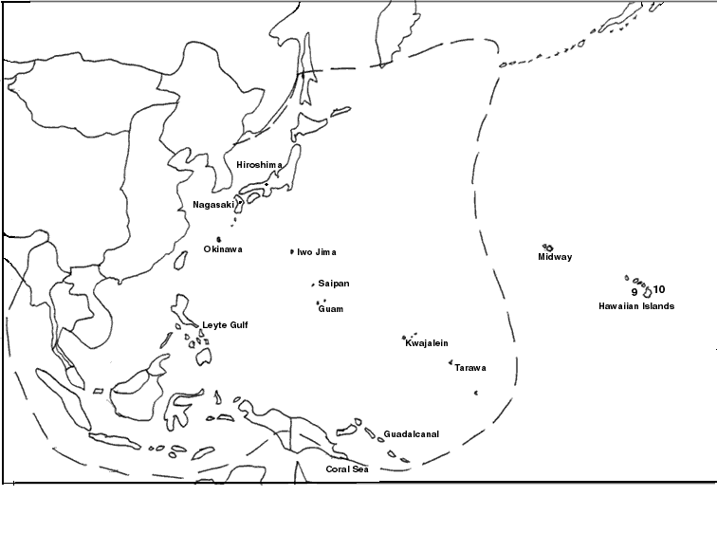
MAP – EXTENT OF JAPANESE CONTROL – by December 1941

DIRECTIONS:
With black pencil/marker, label the following:
China, Manchuria, French Indochina, Philippines, Australia, the USSR
- With red pencil, color in the Japanese island chain.
- With red pencil, trace the dotted line as shown on the map.
- Using the map displayed on the screen, continue to color the areas of Japanese occupation with a red pencil.
- With blue pencil, color in U.S. controlled territory in Dec 1941

